Summer Meeting 20th & 21st June 2019
Programme
Thursday 20th June

TIME | TITLE | SPEAKER |  | FICM CPD
10:00 - 11:00 | Registration and coffee
Session One Chair:
11:00 - 11:45 | Extreme follow-up |  | Dr Matt Morgan  Head of research and development, University Hospital Wales | 3C07
11:45 - 12:30 | Maternal critical care |  | Dr Ingrid Volikas  Consultant in Anaesthetics, BCUHB | 2B06
12:30 - 13:00 | A critical age: the ageing population and critical care |  | Dr Richard Pugh  Consultant in Anaesthetics and Intensive Care Medicine, BCUHB | 3C11
13:00 - 14:00  13:30- 14:00 | Lunch and Industry Fair  Industry satellite symposium
Session Two Chair:
14:00 – 14:45 | Sepsis: from individual response to personalised care |  | Dr Manu Shankar-Hari  Reader and Consultant in Intensive Care Medicine, King's College, London | 2C03
14:45 - 15:30 | Bridging the gap, enhancing care |  | Dr Alison Pittard  Consultant Intensive Care Medicine, Leeds  FICM Vice Dean | 3C06
15:30- 16:00 | Managing nutrition in critical illness: a complex intervention in a complex system |  | Mrs Susan Brierley-Hobson  Head of dietetics, BCUHB | 1I05
16:00 - 16:15 | Tea + Industry Fair
Session Three Chair
16:15 - 17:00 | Keynote address  Practical team-work and communication |  | Professor Peter Brindley  Professor of Critical Care Medicine, Anesthesiology and medical ethics, University of Alberta | 1I02  1I03
17:00 - 17:45 | Annual General Meeting of the Welsh Intensive Care Society  Chair: Dr Richard Pugh
19:30 | WICS Evening Meal

Summer Meeting 20th & 21st June 2019
Programme
Friday 21st June

TIME | TITLE | SPEAKER |  | FICM CPD
09:00 – 11:00 | Session Four: The Ed Major Prize Presentations  Chair: Dr Ceri Battle  Judged by: |  |  | 1I05  3J03
11:00 - 11:15 | Coffee + Industry Fair
Session Five Chair:
11:20 – 12:00 | The present and future of cardiac arrest care |  | Dr Jasmeet Soar  Consultant in Intensive Care Medicine  North Bristol NHS Trust | 1B04
12:00 – 12:40 | Resuscitation ethics |  | Professor Peter Brindley  Professor of Critical Care Medicine, Anesthesiology and medical ethics, University of Alberta | 1F05
12:40 - 13:00 | Care at the end of life |  | Dr Peter Matthews  Consultant in Anaesthetics and Intensive Care Medicine, ABMUHB | 2C06
13:00 - 14:00 | Lunch + Industry Fair
Session Six Chair:
14:00 – 14:45 | The microbiome and critical illness |  | Dr Robin Howe  Consultant Microbiologist, Public Health Wales, University Hospital of Wales | 1E01
14:45 - 15:30 | Paediatric critical care in the non-specialist centre |  | Dr Peter Wilson  Consultant Paediatric Intensivist  University Hospital Southampton NHS Trust | 2D01  2D07
15:30- 16:00 | FICM update |  | Dr Chris Thorpe  Consultant in Anaesthetics and Intensive Care Medicine, BCUHB | 3C12
16:00 | Close, feedback submission and Certificates of attendance

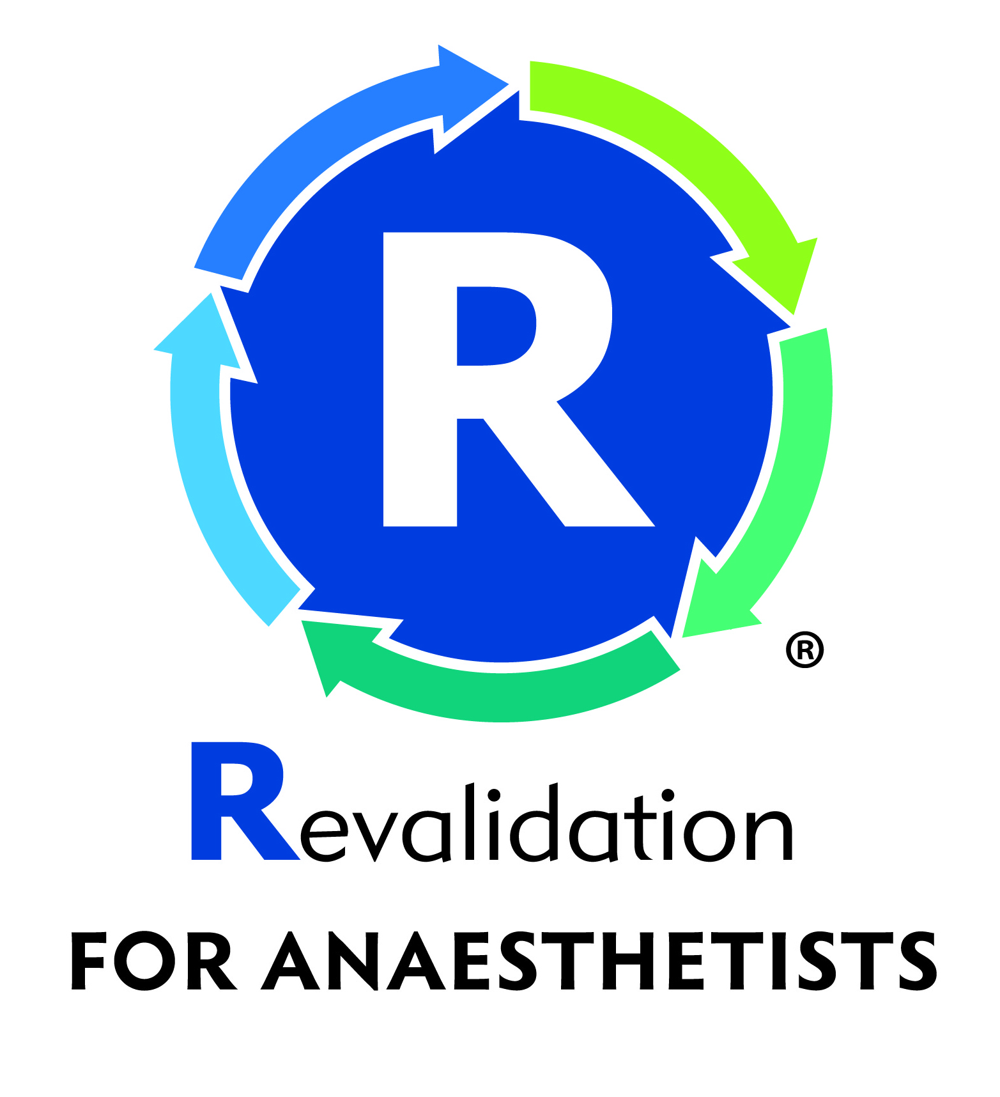
10 CPD Credits (5 per day) applied for:
The Royal College of Anaesthetists
(on behalf of the Faculty of Intensive Care Medicine)

